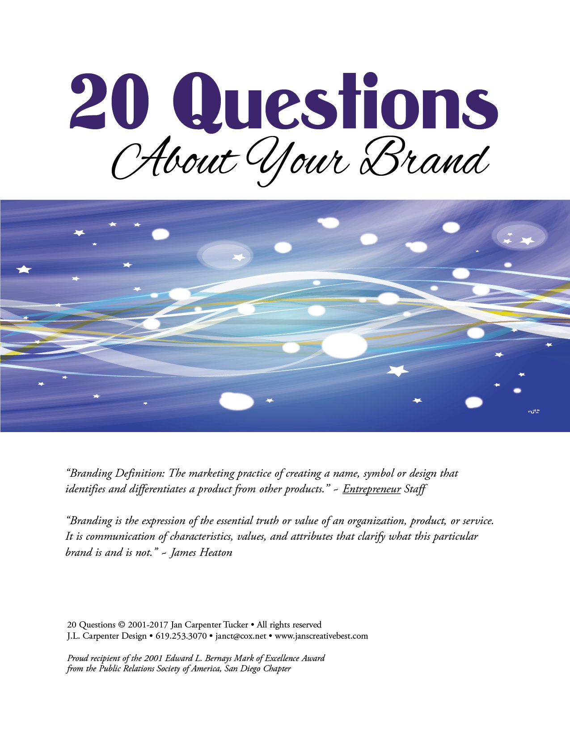
- What product or service do you have to offer?

- Who will use your product or service?

- Who are you communicating your message to?

- What message do you want to communicate?

- What do you want your audience to do, feel or believe about your company/organization, product, or service?

- What do you want to be known for?

- What qualities do you want people to associate with your company/organization, product or service?

- Is there a feeling you want to evoke with your product or service offering? If so, what?

- Is your brand or business image tied to your or someone’s personal identity? If so, give specifics.

- Do you have a favorite color or colors that might work to help convey your message?

- Are there specific images, colors or ideas you need to include or avoid? If so, what are they and why?

- What adjectives would you use to describe your brand (e.g. fun, dependable, artsy, conservative)?

- Who else is offering a product or service like yours?

- Do you have samples of your competition’s collateral or website? If so, attach or provide links.

- What do you think would make your brand or business stand out in a crowd?

- What action do you want people to take?

- What do you think is the best way to reach your target audience?

- What is your budget?

- What end result do you want to achieve with your brand or business image?

- How will you know if your branding or business image is effective?

Please add any other information you think is important to know:

I hope you had fun thinking about your company/organization, product or service brand.

AFTER YOU HAVE ANSWERED AS MANY QUESTIONS AS YOU CAN, PLEASE SAVE YOUR NEW DOCUMENT WITH AN IDENTIFYING FILE NAME.

FOR EXAMPLE: 20 Questions Toni’s Cupcakes.docx

Email your finished document to Jan Carpenter Tucker at janct@cox.net
THANK YOU!

